

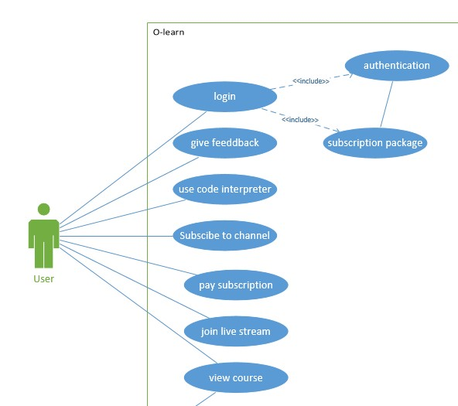

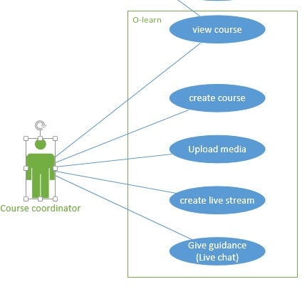

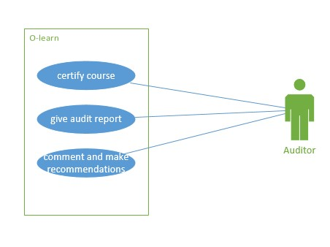

\

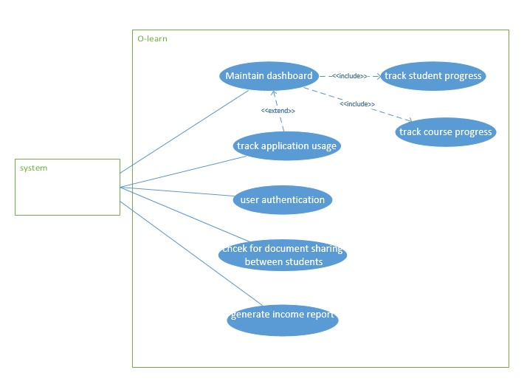

USER-USE CODE INTEPRETER

(BEST)

DESCRIPTION

The user shall use a code interpreter to get correct syntax of C# programming language for correction and debug.

STEP-BY-STEP

1. The user open visual studio
2. Visual studio opens immediately
3. As the user codes the code interpreter give syntax line of code
4. Than the code interpreter debug
5. Gives the intelligence and syntax before user codes

NORMAL

STEP-BY-STEP

1. The user open visual studio
2. Visual studio opens
3. The user codes
4. Check the intelligence and debug

WORSE

1. The user open visual studio
2. It loads and open after a while
3. The use codes
4. Checks syntax and intelligence when the user manually debug

STUDENT Subscribe

DESCRIPTION

The user subscribes to channel after watching videos and listening to audios as an indication of helpful information obtained and pay for it either for monthly, three months, twelve months’ package.

BEST

STEP-BY-STEP

1. The user opens the channel
2. The user listens to audios and watch videos provided
3. subscribes
4. The user leaves comments
5. The user pays

NORMAL

STEP-BY-STEP

1. The user opens the channel
2. Watch the videos provided
3. replays
4. Pays at later stage

WORSE

1. User opens the channel
2. User does not listen and watch media given
3. Subscribes, leaves remarks
4. Never pays

Students courses

DESCRIPTION

The user shall view course to check update and notifications

BEST

STEP-BY-STEP

1. The user open blackboard
2. Provide credentials
3. Finds updates, uploads and notifications
4. View them all
5. Go through each updates and uploads

NORMAL

STEPS

1. Go to blackboard
2. Check update after three days it has been updated

WORSE

STEP

1. User do not open blackboard
2. The user hears from his\her mates about update and notifications
3. The user now check blackboard
4. View courses

SYSTEM-DASHBAORD MAINTENANCE

DESCRIBTION

The system will keep track of all the updated course materials and student performance and overall mark.

BEST

STEP-BY-STEP

1. The course coordinator updates the course materials including the videos and audios
2. The course coordinator modifies the student’s performance
3. The system automatically calculates the overall mark of each student.

NORMAL

STEPS

1. The course coordinator update materials he\she is using for lecturing in class
2. The course coordinator updates the student marks
3. The course coordinator calculates the overall mark for each student
4. Record the overall mark to the system
5. Save the updates

WORSE

STEPS

1. The course coordinator update materials he\she is using for lecturing in class
2. The course coordinator updates the student marks
3. The course coordinator calculates the overall mark for each student
4. Record the overall mark to the system
5. The system is unable to save the changes

SYTEM-USER AUTHENTICATION

DESCRIPTION

The system needs to keep track of the user authentication as to recognise if the user types the incorrect username or password or if someone is trying to breaks in with someone else credentials (safety).

BEST

STEP-BY-STEP

1. The user is using different device to login
2. the system checks if it one person, the usual one
3. the system demands the verifications like cell phone number than sends the verification code to enter before proceeding
4. after providing verification code the system can let you through

NORMAL

STEPS

1. The user is using different device to login
2. User provide correct credentials
3. The system let the user through

WORSE

STEPS

1. The user is using different device to login
2. The user provides correct username but incorrect password
3. It notifies that incorrect password was provided
4. But still let the user login and get through

MANAGER-MANAGES APPLICATION

DESCRIPTION

The manager manages the application(courses). The manager checks for intelligence of the course and the of the course material, the manager also checks the quality of that material before it given to the student.

BEST

STEP-BY-STEP

NORMAL

STEPS

1. The course coordinator sends the course materials including pictures, videos, audios to the manager
2. from what is given the manager checks the quality and intelligence for each.
3. Maintain the university standards
4. Give comment and changes when and where necessary

WORSE

STEPS

1. The course coordinator sends the course materials including pictures, videos, audios to the manager
2. The manager does not have time to check what is given
3. The manager does not communicate with the course coordinator in time or give feedback in time.
4. The course coordinator does not give student the studying materials because he\she still waiting for a manager’s response.

COURSE COORDINATOR-UPLOADS

DESCRIPTION

The course coordinator uploads the materials that will be used in the course like PowerPoint note, images, audios, and videos.

BEST

STEPS

NORMAL

STEPS

1. The course coordinator uploads what It been approved by the manager
2. The student views what is uploaded

WORSE

STEPS

1. The course coordinator does not upload the material
2. The student view nothing